Hello and welcome to Hardware: It’s not just for EE’s anymore!

We hope to relate some of the basic concepts of controlling hardware from the software world as well as controlling software from the hardware world.

For this class we will be putting together a game controller from custom and off the shelf components. One of these components is the “PRO Trinket” Arduino clone from a company named “Adafruit” ([www.adafruit.com](http://www.adafruit.com))

Please have access to the following tools a priori.

1. Download and install the standard Arduino Integrated Development Environment (IDE) from:  
   [Install Arduino Software](https://www.arduino.cc/en/Main/Software)  
    Select the 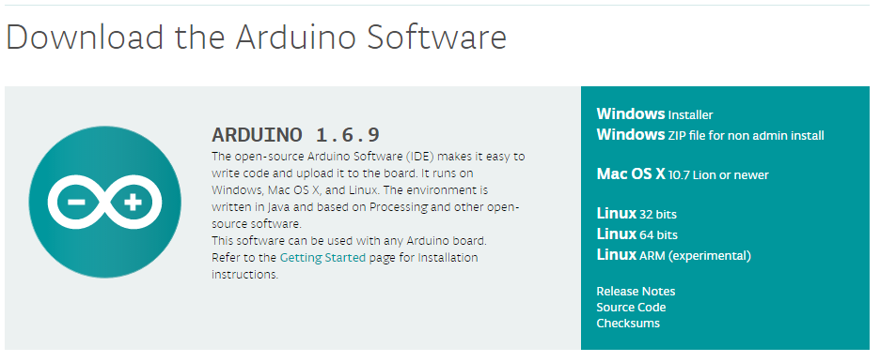
2. Install the USB drivers on your computer. For details on installing the drivers for Windows XP, 7, 8 etc... please read this page (http://adafru.it/cDY)  
   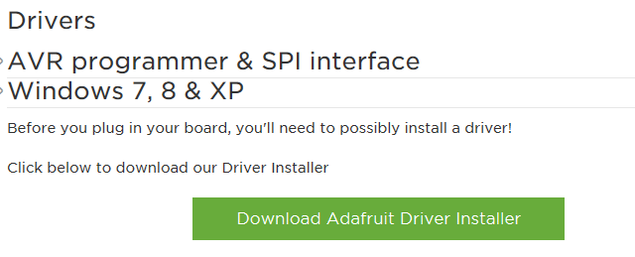
3. MAC users: just install the IDE and plug the controller in.
4. Special Notes on using Pro Trinket with Linux:
   1. Pro Trinket is not supported on Linux operating system at this time - try Mac OS or Windows! However, you can try the following - it does work for some computers
   2. Linux is fairly picky about who can poke and prod at the USB port. You can always run avrdude or Arduino IDE as root, which will make sure you have the proper permissions. If you want to be super-cool you can add a udev rule which will let any user (who is not root) connect to the USBtiny driver. That way you don't have to be root all the time!
   3. Check http://learn.adafruit.com/usbtinyisp/avrdude#for-linux for what to add to your udev file.
5. Arduino IDE Setup: Just follow the steps in the steps in the [Adafruit Arduino IDE setup guide](https://learn.adafruit.com/adafruit-arduino-ide-setup/overview) to easily install a pre-configured Arduino IDE to program Pro Trinket!
6. We will be using the bare Pro Trinket, programming it using the on board USB connector and boot loader. Watch this video to familiarize yourself with the basic process. [Starting the Bootloader](https://learn.adafruit.com/introducing-pro-trinket/starting-the-bootloader)